Chapter 2, Solution 32

Find i₁ through i₄ in the circuit in Fig. 2.96.
16 A
i₁
i₂
200 Ω
50 Ω
60 Ω
i₃
i₄
40 Ω

Figure 2.96
For Prob. 2.32.

Solution

We first combine resistors in parallel.

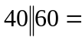 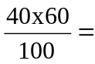 24 Ω and 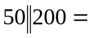 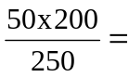 40 Ω

Using current division principle,
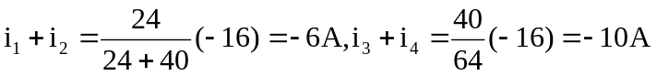

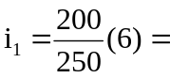 –4.8 A and 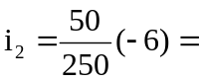 –1.2 A

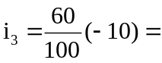 –6 A and 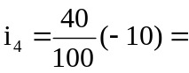 –4 A

